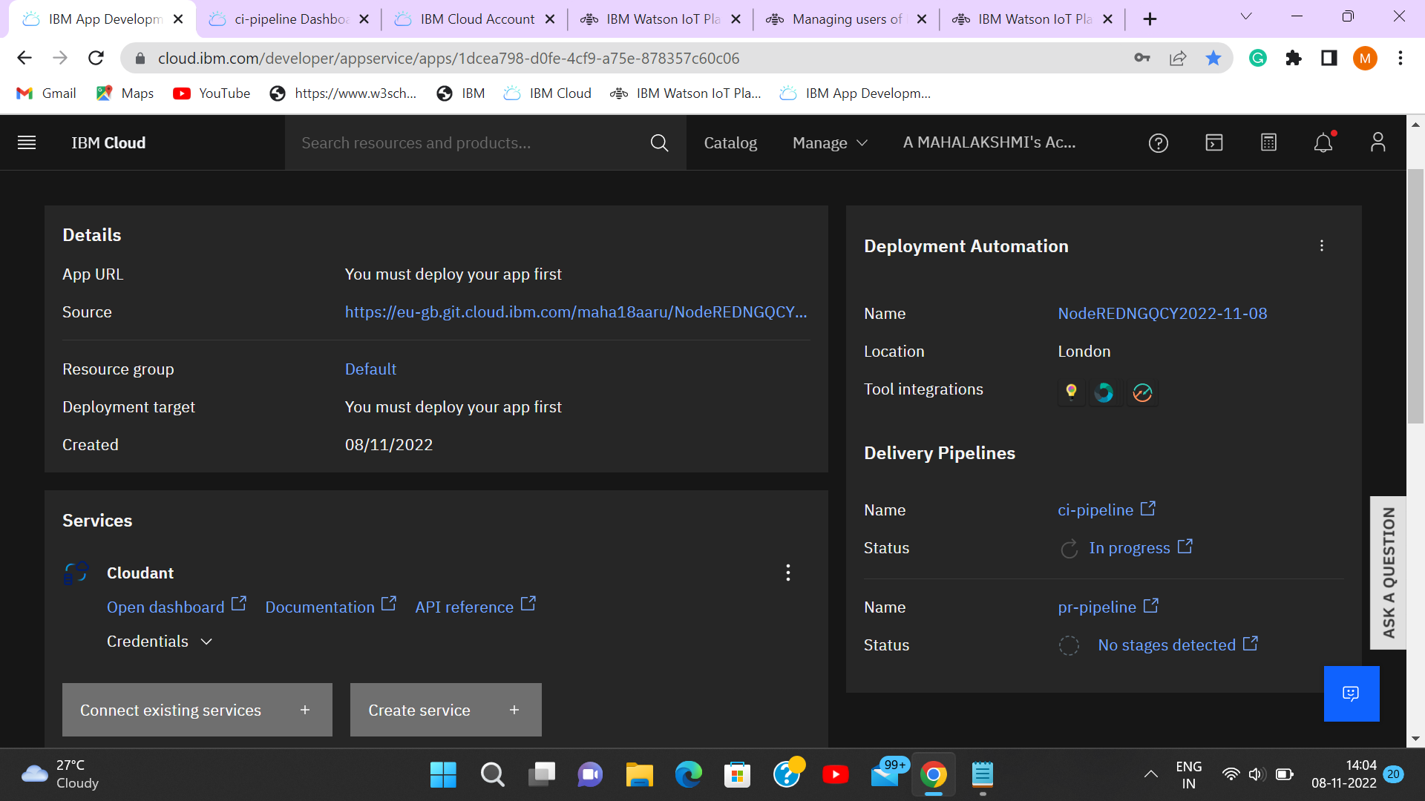



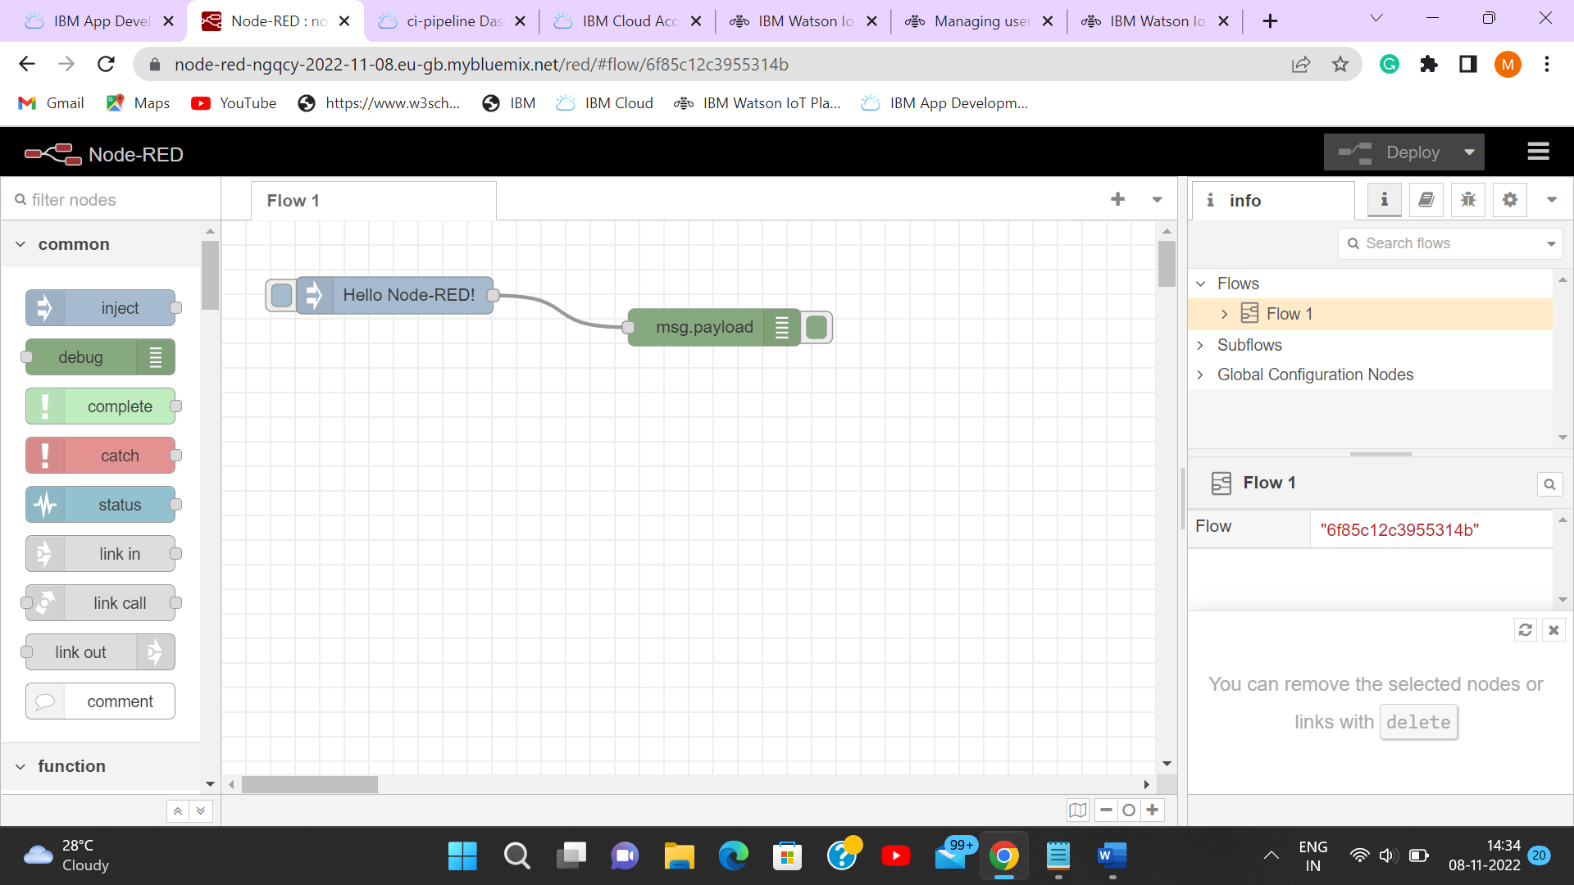

|  |  |
| --- | --- |
| **TEAM ID** | **PNT2022TMID45918** |
| **PROJECT NAME** | **IOT BASED SMART CROP PROTECTION SYSTEM OF AGRICULTURE** |